**EXPERIMENT 6**

Q1. Write a JavaScript code to input your name, residential address, telephone number and display them on separate lines.

Input: -

<!Doctype html>

<html>

<body>

<script type="text/javascript" language= "javscript">

var n,a, ph;

n=prompt("Enter your name");

a=prompt("Enter your address");

ph=prompt("Enter your phone number");

document.write("Name:"+n+"<br>");

document.write("Address:"+a+"<br>");

document.write("Phone number:"+ph+"<br>");

</script>

<body>

</html>

Output: -

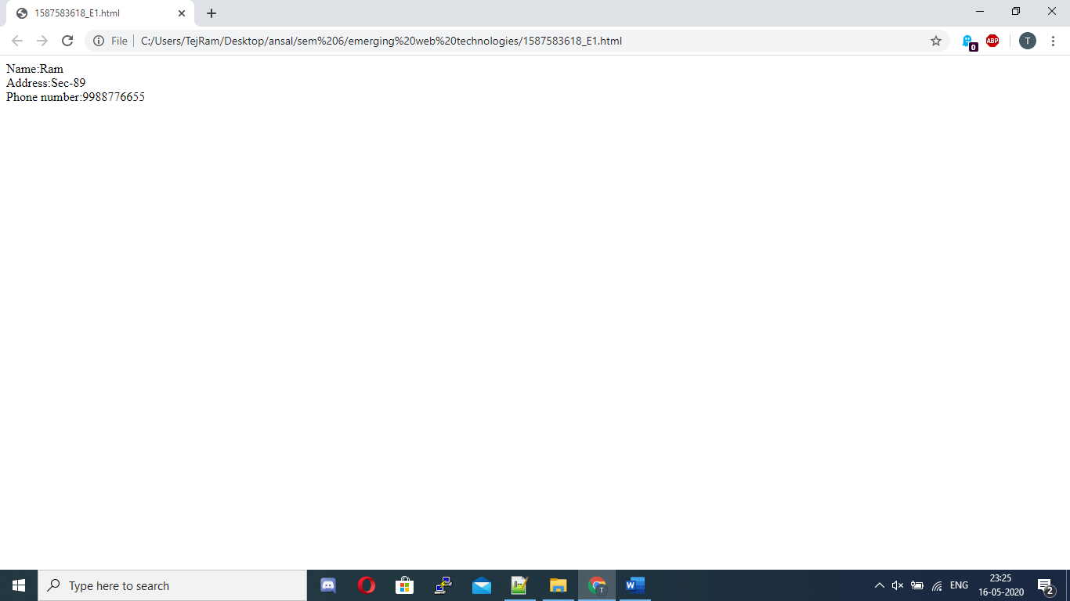

Q2 Write a JavaScript code to input name and age. If name is Vanya and age is 15, then display the statement ‘Vanya is 15 years old’ as output.

Input: -

<!Doctype html>

<html>

<body>

<script type="text/javascript" language= "javscript">

var n,a;

n=prompt("Enter your name");

a=prompt("Enter your age");

if(n=="Vanya" && a==15)

document.write(n+" is"+a+" years old");

</script>

<body>

</html>

Output: -

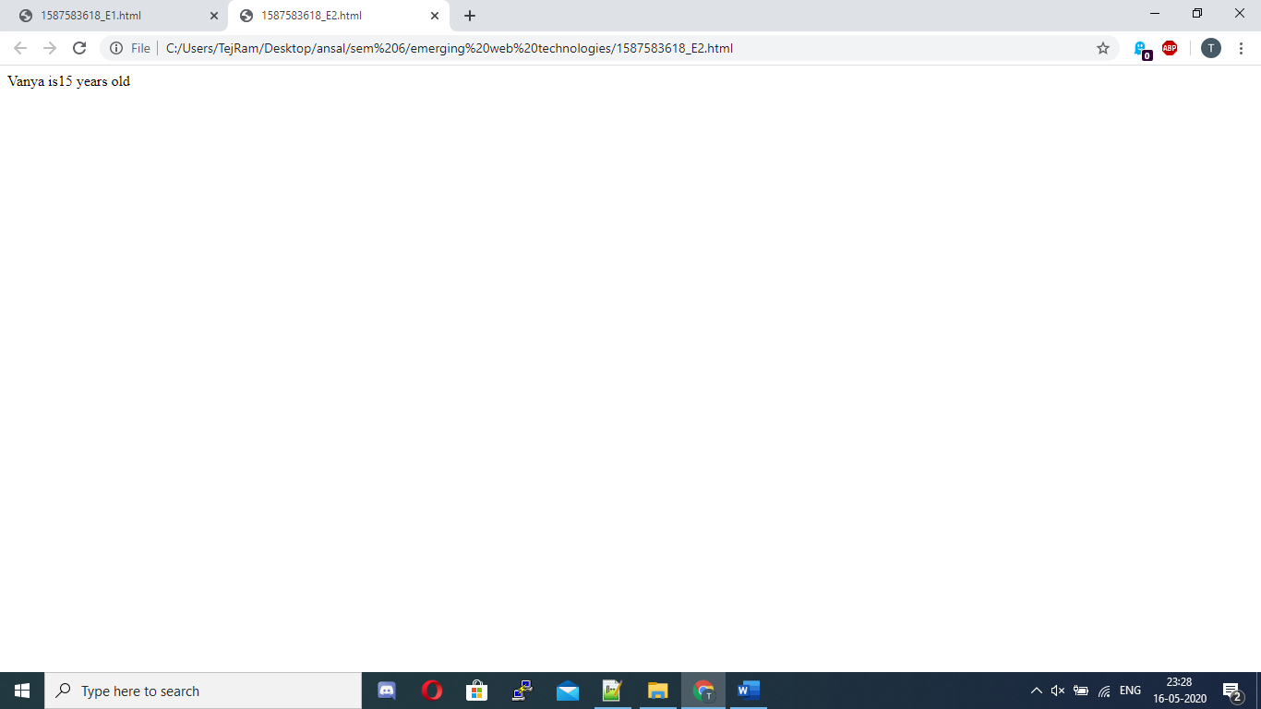

Q3. Write a java script code to display the message “Eligible for vote” in message box, if the following conditions are true:

The age should be >=18,

The nationality should be Indian.

Input: -

<!Doctype html>

<html>

<body>

<script type="text/javascript" language="javascript">

var n,a;

n=prompt("Enter your nationality");

a=prompt("Enter your age");

if(n=="Indian" && a>=18)

alert("Eligible for vote");

else

alert("Not eligible for vote");

</script>

<body>

</html>

Output: -

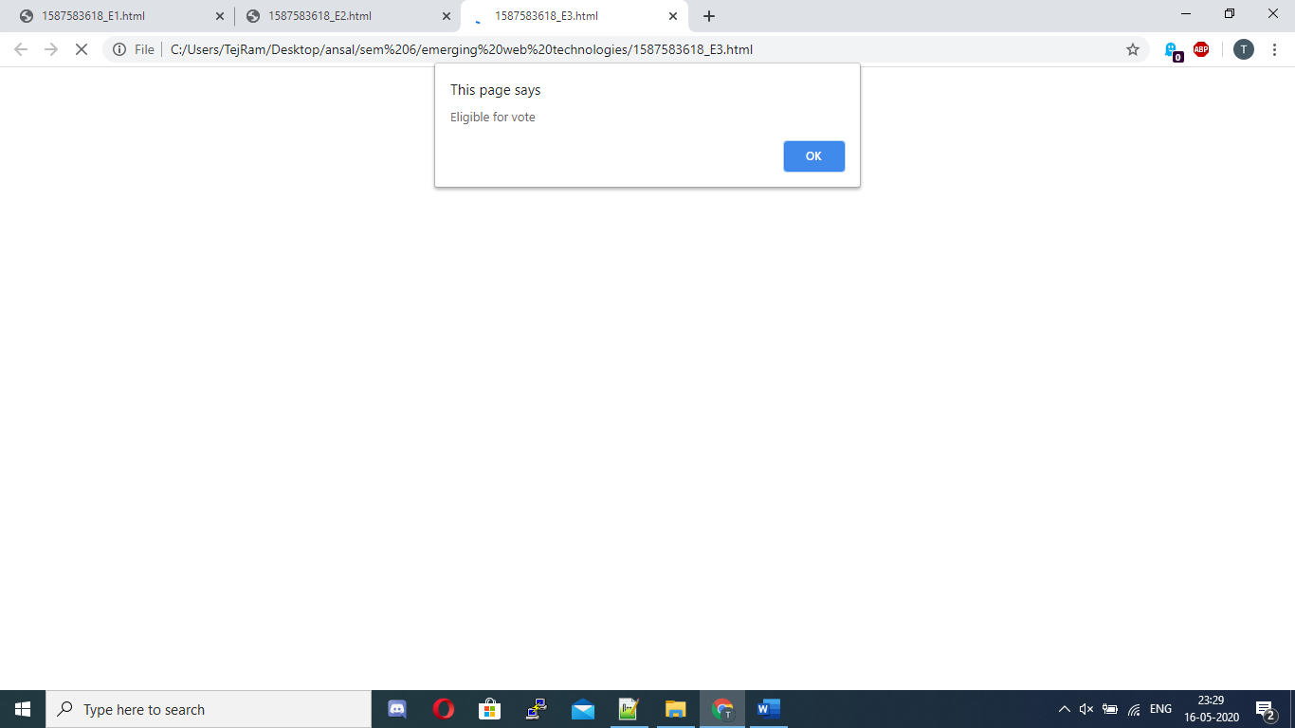

Q4 Write a JavaScript code to input your purchase amount and calculate the discount and net amount based on the following criteria:

Net amount=PA-D

Discount is

2% if PA<=5000

5% if 5000>PA<=10000

8% if PA>10000

Input: -

<!DOCTYPE html>

<html>

<body>

<script type="text/javascript" language="javascript">

var dis,amt;

amt = prompt("Enter purchase amount");

if(amt<=5000){

dis = 0.02;

} else if(amt<=10000 && amt>5000){

dis = 0.05;

} else if(amt>10000){

dis = 0.08;

}

var damt= amt-(amt*dis);

document.write("Amount after discount is"+ damt);

</script>

</body>

</html>

Output: -



Q5. Write a JavaScript code to accept a number from the user and display its factorial. If the user enters a negative number, it should print a message “Please enter a positive number”.

Input: -

<!DOCTYPE html>

<html>

<body>

<script type="text/javascript" language="javascript">

function factorial(n){

if (n<0){

alert("Please enter a positive integer, you entered: "+n);

}else if(n == 0 || n == 1){

return 1;

}else{

return n * factorial(n-1);

}

}

var n = prompt("Enter a number");

var answer= factorial(n);

alert("The factorial of " + n + " is " + answer);

</script>

</body>

</html>

Output: -

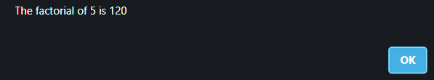

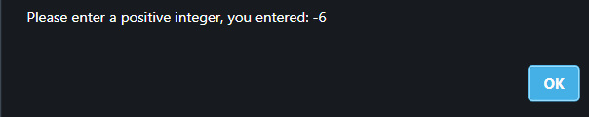

Q6. Write a JavaScript code to display even numbers from 1 to 1000.

Input: -

<!DOCTYPE html>

<html>

<body>

<script type="text/javascript" language="javascript">

for(var i =0;i<=1000;i=i+2){

document.write("\n"+ i);

}

</script>

</body>

</html>

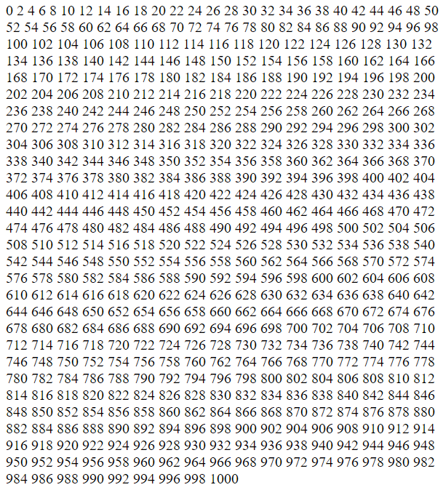Output: -

Q7. Write a JavaScript code to find the sum of numbers between 1 to 20 when incremented by 3.

Input: -

<!DOCTYPE html>

<html>

<body>

<script type="text/javascript" language="javascript">

var sum = 0;

for(var i =1;i<=20;i=i+3){

sum +=i;

}

document.write(sum);

</script>

</body>

</html>

Output: -



Q8. Write a JavaScript code to print all the odd numbers from 15 backward to 3.

Input: -

<!DOCTYPE html>

<html>

<body>

<script type="text/javascript" language="javascript">

for(var i =15;i>=3;i=i-2){

document.write(i + "\n");

}

</script>

</body>

</html>

Output: -



Q9. Write a JavaScript code to print tables from 1 to 10.

Input: -

<!Doctype html>

<html>

<body>

<script type="text/javascript" language= "javscript">

var n,a, p;

n=prompt("Enter a number");

for(a=1;a<=10;a++)

{

p=n*a;

document.write(n+"*"+a+"="+p+"<br>");

}

</script>

<body>

</html>

Output: -

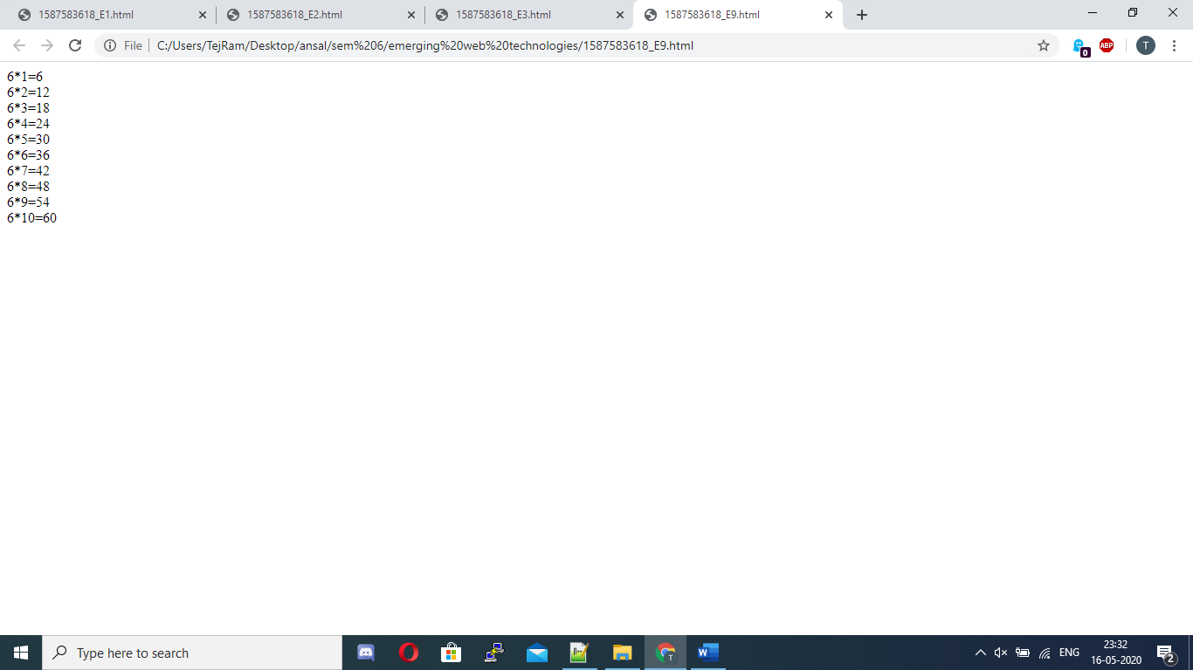

Q10. Write a JavaScript program to check two numbers and return true if one of the numbers is 100 or if the sum of the two numbers is 100.

Input: -

<!DOCTYPE html>

<html>

<body>

<script type="text/javascript" language="javascript">

var a = prompt("Enter first number");

var b = prompt("Enter second number");

if(a==100 || b==100 || a+b==100 ){

console.log("true");

}

</script>

</body>

</html>

Output: -



Q11. Write a JavaScript program to get the extension of a filename.

Input: -

<!Doctype html>

<html>

<body>

<script type="text/javascript" language= "javscript">

var n,a, ph;

n=prompt("Enter file name with extention");

document.write(n.slice(n.lastIndexOf('.')));

</script>

<body>

</html>

Output: -

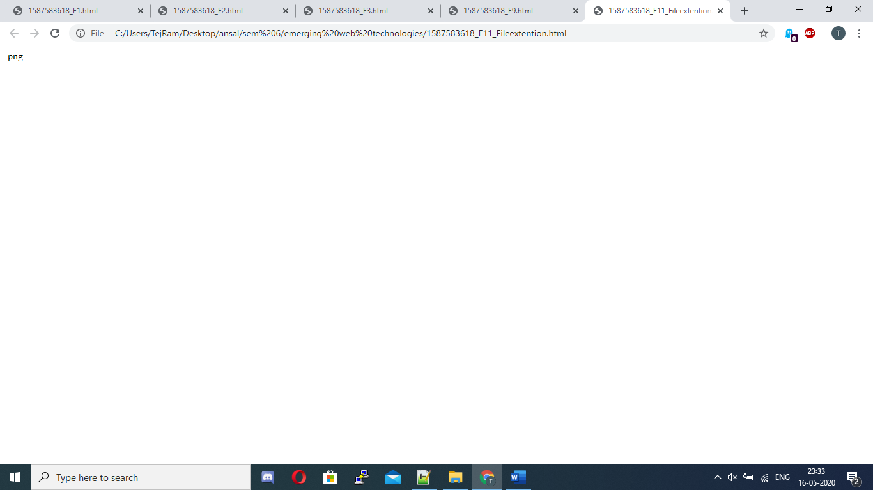

Q12. Write a JavaScript program to replace every character in a given string with the character following it in the alphabet.

Input: -

<!DOCTYPE html>

<html>

<body>

<script type="text/javascript" language="javascript">

function LetterChanges(text) {

var s = text.split('');

for (var i = 0; i < s.length; i++) {

// Caesar cipher

switch(s[i]) {

case ' ':

break;

case 'z':

s[i] = 'a';

break;

case 'Z':

s[i] = 'A';

break;

default:

s[i] = String.fromCharCode(1 + s[i].charCodeAt(0));

}

// Upper-case vowels

switch(s[i]) {

case 'a': case 'e': case 'i': case 'o': case 'u':

s[i] = s[i].toUpperCase();

}

}

return s.join('');

}

var str = prompt("Enter a word");

console.log(LetterChanges(str));

</script>

</body>

</html>

Output: -

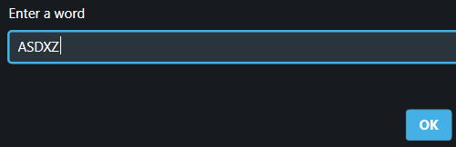



Q13. Write a JavaScript program to get the current date.

Expected output:

mm-dd-yyyy, mm/dd/yyyy or dd-mm-yyyy, dd/mm/yyyy

Input: -

var curday = function(space){

today = new Date();

var dd = today.getDate();

var mm = today.getMonth()+1; //As January is 0.

var yyyy = today.getFullYear();

if(dd<10) dd='0'+dd;

if(mm<10) mm='0'+mm;

return (mm+space+dd+space+yyyy);

};

console.log(curday('/'));

console.log(curday('-'));

Output: -



Q14. Write a JavaScript program to create a new string adding “New!” in front of a given string. If the given string begins with “New!” already then return the original string.

Input: -

<!DOCTYPE html>

<html>

<body>

<script type="text/javascript" language="javascript">

var str = prompt("enter a string");

var st2 = "New!";

if(str.startsWith("New!")){

console.log(str);

}else{

console.log(st2.concat(str));

}

</script>

</body>

</html>

Output: -

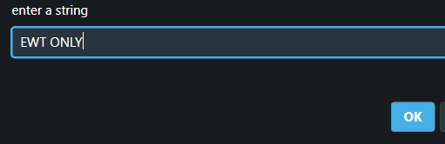



Q15. Write a program in JavaScript to reverse a string

Input: -

<!Doctype html>

<html>

<body>

<script>

// Function to reverse string

function ReverseString(str) {

return str.split('').reverse().join('')

}

// Function call

document.write(ReverseString("qwerty"))

</script>

<body>

</html>

Output: -

